EXPERIMENT-6

ROLL NO: 240701238 NAME: Kathir Vikaas S

AIM:
To simulate the lifecycle stages of UI design using RAD model and develop an interactive interface.

INTRODUCTION
This experiment focuses on simulating the UI design lifecycle using the RAD (Rapid Application Development) model. The application designed is an E-commerce Shopping App that allows users to browse products, select items, and complete purchases easily.

RAD MODEL PHASES APPLIED
1. Requirement Planning Phase
Identified user needs:
● Browse products
● Search items
● View product details
● Add to cart
● Make payment
● Track orders
Decided features:
● Product listing
● Categories section
● Product details page
● Cart and checkout
● Order confirmation

2. User Design Phase
Created UI layout with:
● Home screen with product suggestions
● Categories screen (Men, Women, Kids, etc.)
● Product detail screen
● Cart and checkout screen
● Order confirmation screen
Focus:
● Clean and modern design
● Easy navigation
● Attractive visuals and product display
● Proper spacing and alignment

3. Construction Phase
Developed interactive interface:
● Product browsing and search
● Category selection
● Product detail viewing
● Add to cart and quantity control
● Checkout and payment options
Implemented:
● Smooth navigation between screens
● Clear call-to-action buttons (Buy Now, Add to Cart)

4. Testing & Deployment Phase
Tested with sample user flow:
● Browsing products
● Selecting item
● Adding to cart
● Completing purchase
Verified:
● Navigation flow
● Cart functionality
● Payment process
Final screen shows:
● Order placed successfully message
● Track order option

INTERFACE FLOW
1. Home Screen
● Displays welcome message and product recommendations
● Search bar for finding products
● Icons (wishlist, cart, notifications)
● Users can browse items

2. Categories Screen
● Displays categories like:
○ Women
○ Men
○ Kids
○ Jewellery & Accessories
○ Electronics
○ Home & Kitchen
● Helps users filter products

3. Product Details Screen
● Shows product image
● Product name, rating, and price
● Product description (fabric, fit, etc.)
● “Add to Cart” and “Buy Now” buttons

4. Cart / Checkout Screen
● Displays selected product
● Quantity control (+ / -)
● Address details
● Price breakdown (price, discount, delivery)
● “Proceed” button

5. Confirmation Screen
● Shows success message (“Order placed successfully”)
● Confirmation icon
● “Track Order” button
● “Return” option
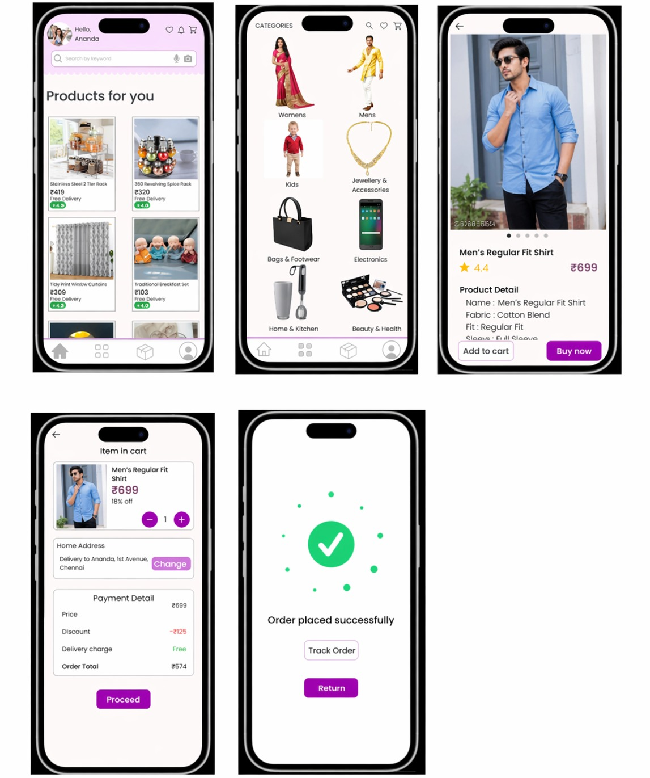

CONCLUSION
This experiment demonstrates how the RAD model helps in developing an interactive E-commerce UI quickly. The application provides a smooth and user-friendly experience, covering the complete process from product browsing to order confirmation.

